July 15,2020
Modern Application Playbook Checklist (Beta)
Citizen Services’ OCIO-ES IMB

https://bcgov.github.io/CITZ-IMB-playbook

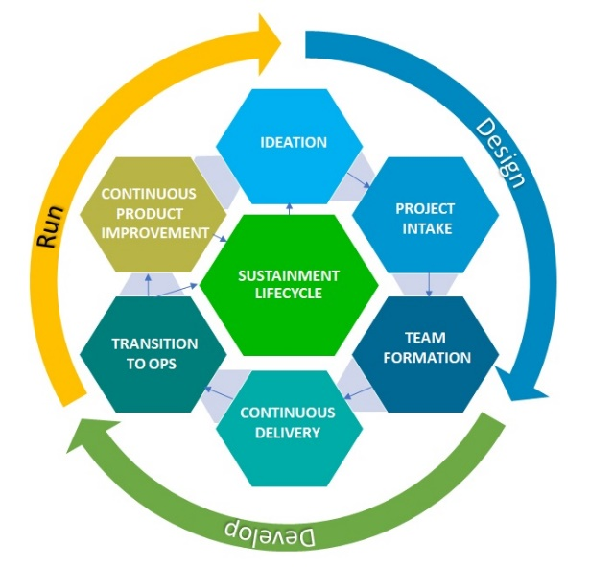
Purpose

This document is a tool that can be used along with the Modern Application Playbook to aid teams in preparing for transitioning of their solutions from ideation, project approval through development and into lifecycle support and sustainment.
This document will be reviewed annually and updated based on user feedback and experience gained in transitioning projects.
Feedback is welcomed and should be submitted here.
Contents
Play 1 3
Ideate Solutions That Meet the Needs of Business 3
Play 2 4
Successfully Navigate the Project Intake Process 4
Play 3 5
Building Your Team 5
Play 4 6
Ready, Refine, Sprint… 6
Play 5 8
Transition to Operations 8
Play 6 8
Continuous Product Improvement 8
Play 7 10
Sustainment Lifecycle 10

Play 1

Ideate Solutions That Meet the Needs of Business
 | Step 1: Promote Innovation from Within | Comment
 | Is the business mandate understood?
 | Are the needs of the user understood?
 | Has any bias been detected?
 | Is creativity encouraged?
 | Are team collaboration activities encouraged?
 | Are visualizations used to convey ideas?
 | Are many ideas being generated?
 | Are peer reviews being used?
 | Step 2: Engage Your Stakeholders | Comment
 | Are wireframes and prototypes being generated?
 | Is feedback being solicited?
 | Are persona’s being use to tell user stories?
 | Are stakeholders reviewing and prioritizing the user stories?
 | Step 3: Proposal Presentation | Comment
 | Prepared for pre-inception work
 | Has a product roadmap been developed
 | Has Business Unit approval been granted

Play 2

Successfully Navigate the Project Intake Process
 | Step 1: Obtain Business Unit Endorsement | Comment
 | Is the project initiation process being followed?
 | Has a business/concept case been developed?
 | Is there a senior business consultant working on the project?
 | Has an operating model been developed?
 | Has “done” been defined?
 | Has a sustainment lifecycle been defined that will help clarify who will operate and maintain the product?
 | Step 2: Follow the Ministry IM/IT Project Intake Process | Comment
 | Have the project initiation steps been followed?
 | Has the project been registered in the ministry project tracking system
 | Has the project proposal been introduced to the project review board?
 | Hs the project proposal been introduced in the architecture review board?
 | Step 3: Determine Project Resourcing | Comment
 | Has resourcing been considered for this proposal?
 | Is a partnership agreement or memorandum of understanding required?
 | Step 4: Provide Regular Updates | Comment
 | Are reporting updates scheduled at appropriate times for the class of project being considered?
 | Are project updates being published in the ministry project tracking system?

Play 3

Building Your Team
 | Step 1: Go Agile | Comment
 | Is the project using an agile methodology?
 | Have team members and stakeholders taken agile training?
 | Step 2: Augment your team with experience | Comment
 | Have all roles been identified for the project?
 | Is a security and privacy officer part of the team?
 | Has a product owner been identified?
 | Have CodeWithUS and SprintWithUS been considered to augment the team makeup?
 | Step 3: Introduction to the Product Vision | Comment
 | Have sll team roles been defined and allocated?
 | Does the team understand the approval process for signing off on deliverables?
 | Has the product owner presented the solution vision to the team?
 | Does the client understand the risks involved (if any)?
 | Does the team have a list and understanding of the tooling they require?
 | Has a reporting strategy for communicating progress to stakeholders been identified?
 | Has the Project Inception Agenda been created?
 | Step 4: Project Inception | Comment
 | Have the teams’ values been created and displayed?
 | Has a team agreement been mutually agreed upon?
 | Has the “way of working” been identified?
 | Has a common “definition of done” been agreed upon?
 | Has virtual/physical team space been agreed upon?
 | Has the development environment been defined and procured?
 | Has an initial backlog of requirements/stories/features been created?
 | Have the user stories been prioritized?
 | Has acceptance criteria for each story been defined?

Play 4

Ready, Refine, Sprint…
 | Step 1: Develop a Release Plan | Comment
 | Has the (initial) backlog been refined?
 | Has the product release schedule been defined?
 | Have all dependencies been documented?
 | Step 2: Develop Your Conceptual Architecture | Comment
 | Have the system architecture, components and relationships been developed and documented?
 | Step 3: Adhere to Modern Application Principles | Comment
 | Is the project cloud-based or cloud ready?
 | Is the solution conforming to the 12 factors application methodology?
 | Step 4: Set up Your Technical Infrastructure | Comment
 | Does the team have IDs and access rights to all required systems?
Has the team communication channel been defined and set up
(ex: MS-teams/ Rocketchat/ Slack)?
 | Has the documentation repository been created and setup, all team members are aware of the structure?
 | Have the technical environments been setup and tested?
 | Step 5: Identify Your Development Workflow Processes | Comment
 | Has the development workflow been documented?
 | Step 6: Set Up, Document, and Implement Your Tooling (Code Repository, Pipelines, Automation) | Comment
 | Does the team have access to and know how to publish to the code repository?
 | Does the team have a shared understanding of the code delivery process?
 | Has the product delivery manager verified all processes?
 | Has an application security framework review occurred?
 | Step 7: Educate Your Business Stakeholders | Comment
 | Are the business stakeholders regularly updated on the project’s status, budget and features?
 | Are change management processes being followed?
 | Step 8: Now Sprint… | Comment
 | Has Sprint 0 occurred, and is the team able to start working?
 | Are sprint ceremonies being followed and documented for review?
 | With each sprint, is the Scrum master looking for opportunities to improve the team’s efficiency?
 | Step 9: Conduct Code Reviews | Comment
 | Are the code review results posted for all to review?
 | Is there a need to modify coding standards?
 | Do the automated code testing processes reduce the need for manual reviews? Are the logs being read?
 | Step 10: Complete User Acceptance Testing and Remediate Defects | Comment
 | Are the tests being maintained? Reviewed? What is the % of pass to failure? What is the process to remediate defects? What is the mean time to remediation?
 | Step 11: Deploy and Promote Through Your Environments | Comment
 | How many pull requests are occurring during a sprint? Is this related to package/feature sizes?
 | How often are the environment logs being reviewed?
 | Step 12: Demonstrate Your Products Frequently and Obtain User Feedback | Comment
 | How often are product & feature demos being held? How many features are deprecated as a result of feedback from demos? How many features are changed as a result of demos?
 | Step 13: Monitor and Measure the Development Process | Comment
 | Is the rate (velocity) of development keeping up with expectations?
 | Is the deployment pipeline being monitored and measured regularly?

Play 5

Transition to Operations
 | Step 1: Review the Memorandum of Understanding | Comment
 | Are changes required?
 | Are commitments being upheld?
 | Step 2: Complete Knowledge Transfer | Comment
 | Does a knowledge transfer plan exist? How often has it been reviewed? Are changes required?
 | Do roles exist to inherit the body of work?
 | Is there an education plan for the staff receiving the work?
 | Step 3: Validate Operations Processes | Comment
 | Does the transition document include a “rebuild/install” document?
 | Has a clean build on a different local environment been validated? Does it match the documentation?
 | Has the change management plan and processes been reviewed?
 | Have all the operations processes been validated? Deficiencies identified and a remediation plan initiated?
- Review the IMB Application Transition Checklist

Play 6

Continuous Product Improvement
 | Step 1: Incorporate Feedback | Comment
 | How frequently is product usability being reviewed with end users and stakeholders?
 | How is feedback being categorized?
 | What percentage of feedback is actioned?
 | As a result of feedback being incorporated into the product do you see greater adoption ? Usage? User satisfaction?
 | Are the target metrics being met? Can some be deprecated? Others added?
 | Step 2: Maintain Product Vision | Comment
 | How frequently are the stakeholders being asked to reaffirm the product vision?
 | What is on the Kanban? How big is the backlog? How often is backlog grooming occurring? Are there any noticeable trends?
 | Step 3: Conduct Process Improvement Reviews | Comment
 | What is the typical size of tasks? What is the optimal size for the team to maintain its velocity?
 | Based on code reviews and analysis of user flow through the solution are there any features that can be deprecated?
 | Step 4: Prioritize Bugs and New Feature Requests | Comment
 | What is the current bug count?
 | Has the defect log been reviewed? Are the types of bugs being lowered? In what modules do they most frequently occur?
 | How long does it take to remedy identified issues/bugs?
 | Step 5: Ongoing Code/Build/Deploy/Release Management | Comment
 | Are code reviews identifying fewer issues?
 | When was the documentation last reviewed?
 | Has the image build timing been reviewed can it be optimized?
 | Has the release roll back plan been validated?
 | Has the STRA/PIA been reviewed for updates based on platform updates or feature changes?
 | Has a dependencies test been conducted?
 | Step 6: Skills Retention Requires a Plan | Comment
 | Does the project have a roles-based succession plan?
 | Is there an opportunity to onboard temporary assignment or co-ops?
 | Do team members communicate their skill-enhancement activities through lunch time learning or webinars or other channels?
 | Step 7: Communicate Your Success | Comment
 | What blogs, newsletters, webinars do the team use to inform the community and potential stakeholders?

Play 7

Sustainment Lifecycle
 | Step 1: Maintain a Happy User | Comment
 | Has a product review been undertaken that affirms goals and objectives are being met from both the end user and the business’ perspectives?
 | Has a market survey of similar products been conducted? How does this solution compare?
 | Based on user and stakeholder feedback and available analytics are there any features that are desired are there features that can be deprecated?
 | Review product roadmap & release schedule, prioritize new feature opportunities.
 | Step 2: Maintain Product Funding | Comment
 | Have the current budget assumptions been affirmed?
 | Are there opportunities to lower costs?
 | Step 3: Maintain Vendor/Partner Relationships | Comment
 | Are there changes to existing vendor/partnership agreements? Do they impact the product roadmap?
 | Are there any changes to licensing that impact the product roadmap?
 | Are there any changes to platform support agreements that could impact the product roadmaps?
 | Step 4: Continuously Improve Overall Lifecycle | Comment
 | List what process reviews have been done and where improvements where identified
 | List improvement experiments undertaken and describe lessons learned
 | Step 5: Maintain Product Integrity & Quality | Comment
 | Reviewed defect log for improvement opportunities
 | Reviewed platform release cadence aligned with product releases for possible feature impacts

